PG22 Maverick V2 - .22 Short Revolver
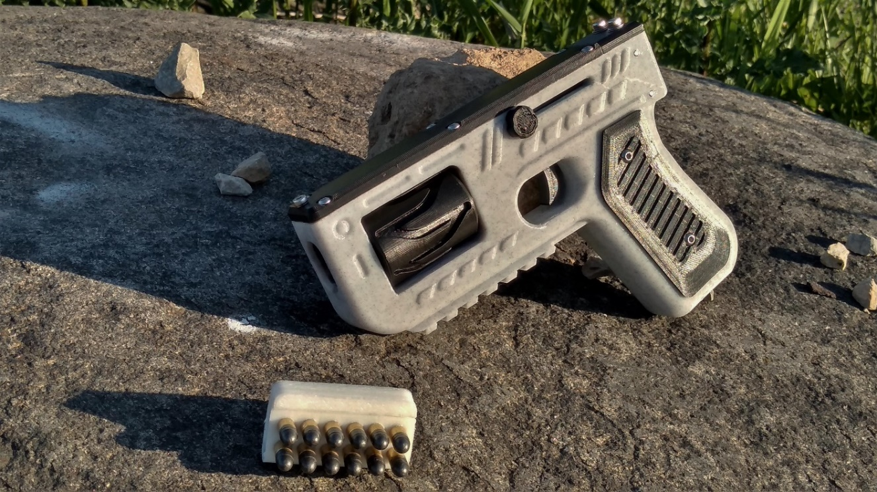
Subscribe to https://Youtube.com/user/Pilotgeek for latest build guide.

Disclaimer
Please read and understand this manual fully before attempting assembly. This product is not print-in-place. This design requires skilled machining and assembly of additional components for complete assembly. You will need a rotary tool with cutoff wheel at minimum. These plans are intended for educational purposes only and assembly is at your own risk.
The Maverick ONLY works with .22 short cartridges. 22lr will not feed in this design, nor should it be attempted. You have been warned.
The Maverick is an experimental hobbyist project. It is not designed to be carried, and it is not intended for self-defense. The current design does not feature proper modern safeties and should be used in a controlled environment with careful handling.
These plans are provided as-is. They should be treated as a novelty, and nothing more. These files are not an actual gun, they are CAD files depicting design of a handgun. They require skill and knowledge to make into a functional object. You are responsible for knowing the laws regarding firearms where you live. Before building, please read up on all applicable gun laws and decide for yourself whether or not you can legally build this where you live.

Read all instructions carefully. Do not skip or skim. It’s all here for a reason.

Parts Index - Required Parts
  - Amazon links are paid / sponsored links. Links may change or disappear depending on sellers and availability.
- M3 Screws – Button Head Assortment - https://amzn.to/2C1ez2X
- M3 Screws - Cap Head Assortment - https://amzn.to/2YAIgQ1
- M5 x 65mm Cap Head Screw - https://amzn.to/2Bc0XRY
- Epoxy (Don’t use Quick Setting) - https://amzn.to/37vCumZ
- 22 Caliber Rifled Barrel Liner - 5/16" OD - https://www.gunpartscorp.com/products/588180
  - OR Smaller .305” OD Variation: https://www.gunpartscorp.com/products/1574750
- Firing Pin (1/16" Drill Bit) - https://amzn.to/37kLv0F
- Plastic Safe Grease - https://amzn.to/2F3pUxO
- 5/16” Ball Bearing - https://amzn.to/2M4YJq6
- 3MM Guide Rods - https://amzn.to/2Bu0RFK
- Striker Spring: 0.8mm x 6mm x 50mm Stainless Steel Compression Spring
- Return Spring: .025 WG ¼” Compression Spring cut to 80mm length. Midwest Fastener 88279.

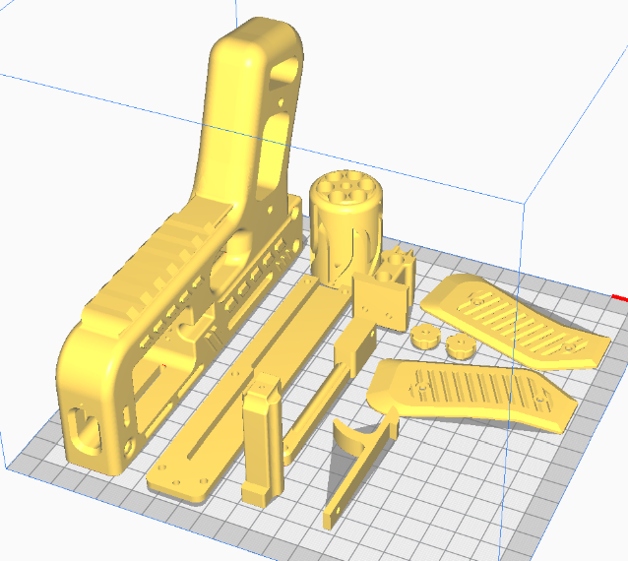
3D Printing

General Settings
- Nozzle: 0.4mm
- Material: High-Quality PLA –PETG or Nylon may work. ABS has not been tested.
- Slicer: Confirmed to print correctly on Cura 3.6 through 4.5
- Print in the orientations shown below. Print each part separately for best results.

Print Settings
- Print all parts 100% Infill. If you cannot print 100%, use thick walls (4-5 layers) & min 35% infill.
- Supports
  - Mostly needed on frame, for cylinder overhang.
  - Pattern: Zig-Zag
  - Density: 15-20%
  - Print Frame with a large brim or raft. This was the easiest way I found to prevent the frame from warping. A heated build plate is required. I recommend an enclosure.
- Notes
  - Don't try to print too fast, you want it to be good. Even when using PLA, it helps to build in a warmer environment for strong layer adhesion and less warping.
  - Low quality prints may require sanding. Polish any mating surfaces or moving parts.
  - If available, use plastic-safe grease on all moving parts. It will ease trigger pull & wear.

Metal Parts

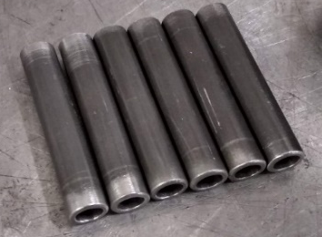
Barrels & Cylinder
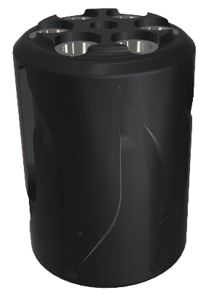
Use a small pipe cutter, rotary tool, or hacksaw to cut the barrel liner into six sections approximately 45mm in length. Use a grinder or sandpaper to finish each barrel to 44mm length. Each barrel should be exactly the same length! Once each barrel is the correct length, ream a chamber using a #1 wire drill. A vice clamp and BarrelClamp.stl is recommended. Chamber depth should be approximately 14mm.
Use an 8mm or 5/16” drill bit to finish the holes in the plastic cylinder. If cylinder is too loose or tight, you may need to print alternate cylinder files. Clean and rough-sand each barrel and coat with JB Weld or similar epoxy. Lightly coat interior of plastic cylinder with epoxy. Press the barrels into the cylinder using a c-clamp or bench vice. I recommend using a spent casing to seal the end from epoxy, and as a template for headspacing. A chambered case head should be flush with the end of the cylinder for proper headspacing. Q-tips and pipe cleaners should be run through each barrel to ensure they are free of epoxy. DO NOT USE QUICK SETTING EPOXY.

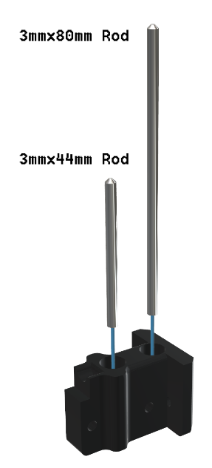
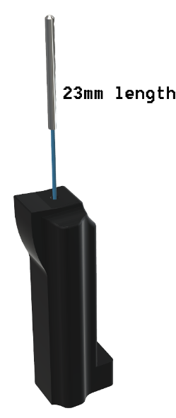
Firing Pin & Striker
Finish the hole on the striker for the firing pin using a 1/16” drill bit, then cut the bit’s shank to 23mm length. Chamfer the tip to a chisel point, leaving a flat face of about 0.5mm width. Clean and polish the firing pin, ensuring edges are not too sharp. Align the firing pin’s point vertically, and secure into the striker using a strong epoxy. Test in the frame, and ensure the firing pin protrudes around 1mm.

Springs & Guide Rods
Cut 3mm rod to 80mm, and another to 44mm. Round and polish one end of each. Press fit the flat end of the rod into the rear receiver plug, using a strong epoxy to secure.
Cut ¼” spring stock to 80mm and 8mm lengths. Set aside for assembly.

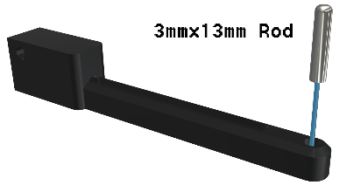
Indexer
Cut 3mm rod to 13mm in length. Round and polish one end. Press fit the flat end of the rod into the indexer linkage, using a strong epoxy to secure. Cut a second length of rod to 34mm, and set aside for assembly.

Assembly

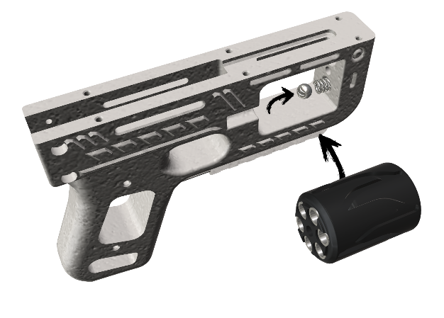
Cylinder & Ball Bearing
Fit the 5/16” ball bearing and spring into the front of the frame. The Spring should be around 8mm uncompressed, and 3mm compressed. Sand the frame if necessary, the ball should freely move in and out of the frame without sticking. Use plastic safe grease on the ball bearing. The ball bearing should be able to push flush with the frame for proper cylinder rotation.
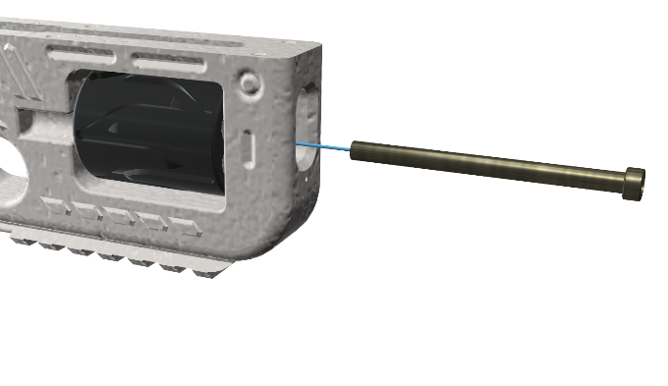
Grease the center hole of the cylinder, and use a 65mm M5 bolt to secure the cylinder assembly in the frame. The ball bearing should provide enough resistance to firmly and securely click into each barrel position, but still smoothly rotate between barrels without having to force. You may need to add a washer between the cylinder and the front of the frame depending on tolerances and whether or not material was removed from sanding.

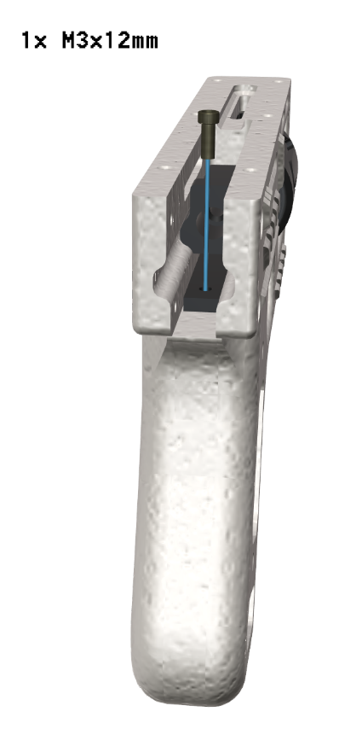
Trigger & Striker
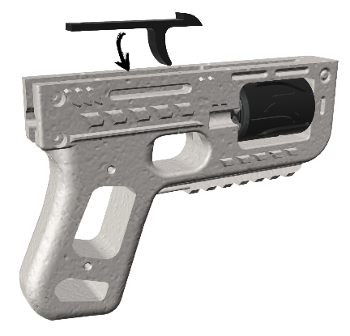
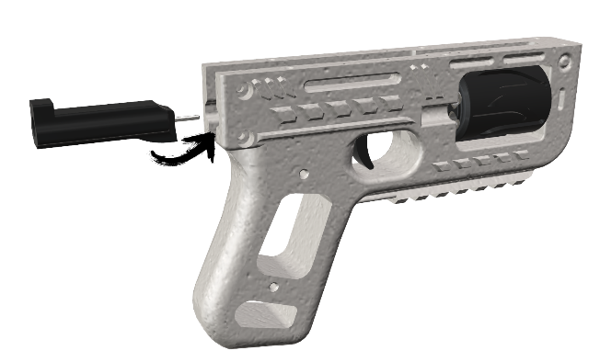
Set trigger into frame rails from the top. Align with screw hole, but do not install screw yet. Place the striker into the frame rails from the rear. Sand any sliding surfaces to remove rough finish, and use plastic safe grease for best operation. The striker should slide forward and backward in the rails with minimal resistance. Push the striker to the full forward position. Use an M3x12mm screw to secure the trigger to the frame.

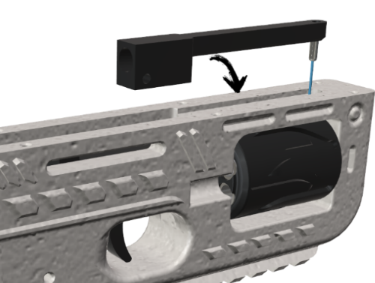
Indexer & Charging Handle
Place the indexer fully forward into the slot on the top of the frame, ensuring the metal follower aligns into the cylinder grooves.
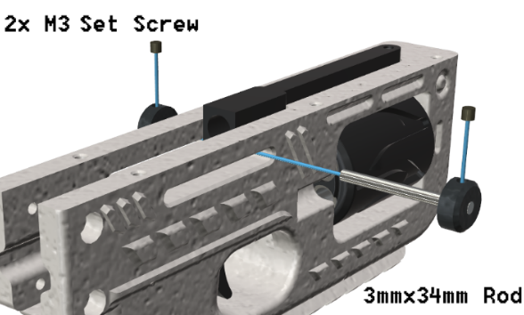
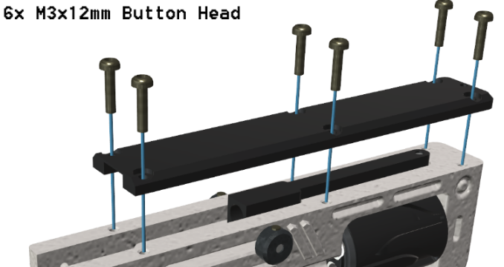
Press the 34mm rod through the slot in the side of the frame, going through the indexer. Press fit the charging handle knobs onto each end of the rod, and secure with M3 set screws. Use 6x M3x12mm button head screws to secure the top cover.

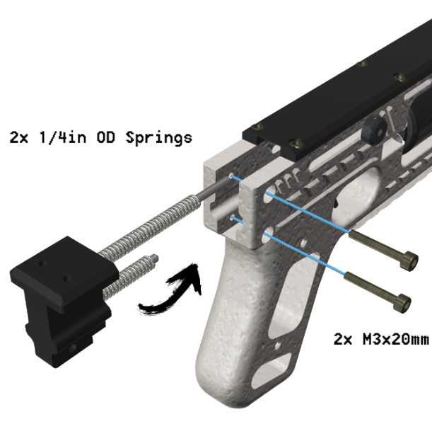
Springs & Guide Rails
Install a .025WG ¼” Spring cut to 80mm length on the upper indexer guide rod. Ensure it can be fully compressed.
The striker spring is sized for a ¼” OD spring. For reliable primer ignition, wire gauge should be around 0.8mm or 0.030WG. I ultimately used a 0.8mm x 6mm x 50mm steel spring, which resulted in very reliable primer strikes.
Make sure both sets of guide rods and springs align correctly, then use 2x M3x20 mm screws to secure the guide rods / receiver plug into the frame.

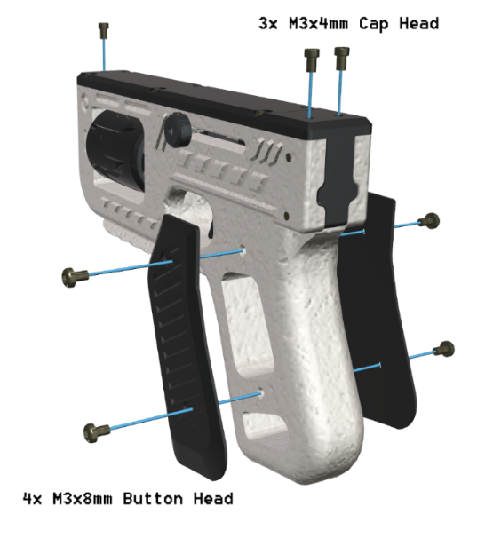
Grips & Sights
Use high-strength epoxy to permanently affix at least 2-3oz of steel weights into the grips to ensure metal detection. The file GripWeights.stl is included as an adapter for pinewood derby car weights. Use 4x M3x8mm button head screws to secure the grips.
Sights use M3 x 4mm cap head screws, and can be screwed into the top cover and rear plug. Sights may need to be adjusted for elevation.

Safety & Usage
TEST FIRE THE GUN REMOTELY. Secure the gun to a solid surface and fire remotely with a string attached to the trigger.
Inspect the condition of the gun during and after each session of usage. Discard any parts which show excessive wear. Always wear safety glasses and ear projection when firing. You do not want ear or eye damage from vented gases in the case of cartridge failures.

Loading & Ejection
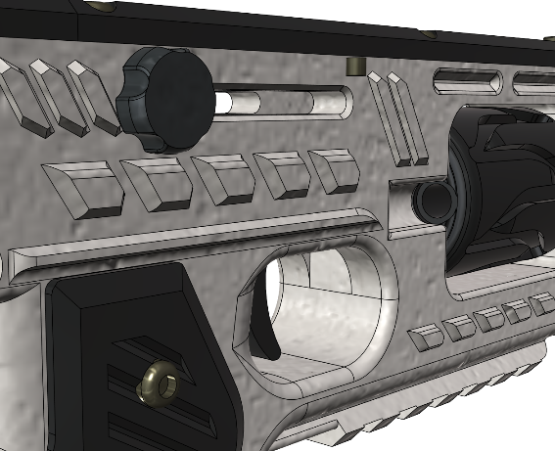
The Maverick is designed to use .22 short ammunition, which is loaded or ejected through the small window on the right side of the frame. This window aligns on the rear pull of the charging handle. Use two fingers on the charging handle, and brace the rear of the frame with your thumb to hold the cylinder in position while loading and ejecting. Ejection may require use of a fingernail to pull stuck cases free of the chamber. Advance to the next chamber by cycling the charging handle until all 6 cylinders are loaded or ejected. Always keep the Maverick pointed in a safe direction. The striker is cocked and live after the first pull of the charging handle.

Decocking
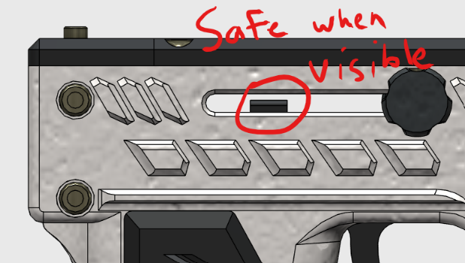
If you will not be immediately firing the Maverick, it is possible to decock the striker. While keeping the Maverick pointed in a safe direction, firmly hold the charging handle to the rear; pull the trigger and slowly ease the charging handle forward. You will see the striker tab through the side of the gun to indicate it is now safe. Note* Firing pin will drop between cylinders using this method. Cylinder may not fully rotate until cocked again.

Firing
The Maverick is cocked and ready to fire after the first pull of the charging handle. The Maverick operates similar to a single action revolver, and the trigger will only function to release the striker. Once fired, pull the charging handle to cock the striker, and advance the cylinder to the next chamber.

Legality
The PG22 Maverick is a CAD representation depicting theoretical design of a handgun. These plans are provided as-is for entertainment and educational purposes only. I am not liable for any injury or damage resulting from using these files. These plans do not represent a complete functional 3D Printed handgun, but a frame and components which require additional tools, materials, and knowledge to make into a functional object. You are responsible for knowing the laws regarding firearms where you live. Before building, please read up on all applicable gun laws and decide for yourself whether or not you can legally build this where you live.
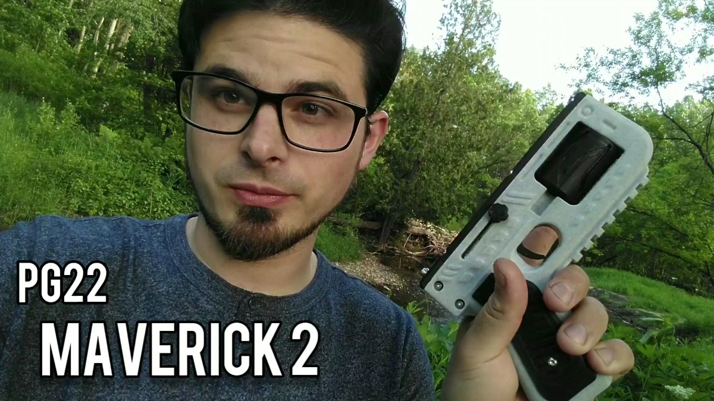
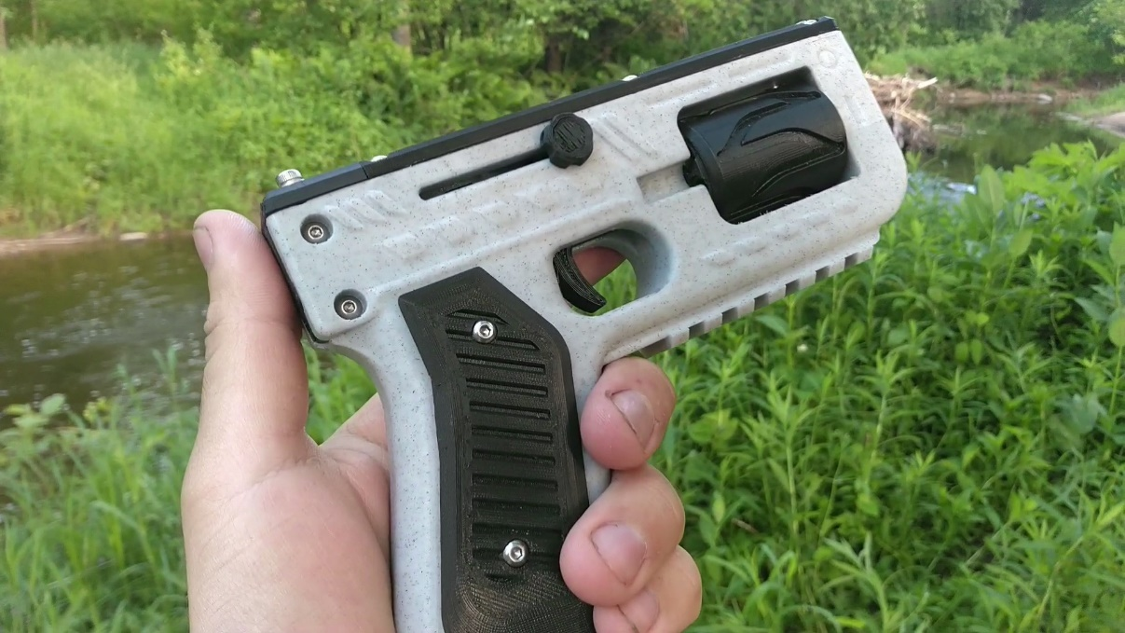
https://www.PilotHobbies.com/PG22
https://www.youtube.com/user/Pilotgeek

